IMPLEMENTATION OF SELECTION SORT AND BUBBLE SORT ALONG WITH TIME AND SPACE COMPLEXITY EVALUATION

PROGRAM 1: SELECTION SORT

#include<stdio.h>
void main()
{
int min_index,n,i,j,count=0;
count++;
printf("Enter the no. of Elements: ");
scanf("%d",&n);
count++;
int array[n];
printf("Enter the elements: \n");
for(i=0;i<n;i++){
count++;
scanf("%d",&array[i]);
count++;
}
count++;

for(i=0;i<n;i++){
count++;
min_index=i;
count++;
for(j=i+1;j<n;j++){
count++;
if(array[j]<array[min_index]){
count++;
min_index=j;
count++;
}
count++;

}
count++;
int temp=array[i];
array[i]=array[min_index];
array[min_index]=temp;
count++;
count++;
count++;
}
count++;

for(i=0;i<n;i++){
count++;
printf("%d\t",array[i]);
count++;
}
printf("\nTime Complexity=%d \nSpace Complexity=%d",count,6*4+4*n);
}

OUTPUT 1

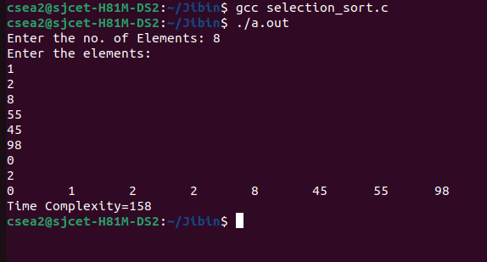

PROGRAM 2: BUBBLE SORT

#include <stdio.h>
void main()
{
int n,i,j,a[100],swap,count=0;
count++;
printf("Enter the number of elements:");
scanf("%d",&n);
count++;
printf("Enter the elements: \n");
for(i=0;i<n;i++)
{
count++;
scanf("%d",&a[i]);
count++;

}
count++;
for(i=0;i<n-1;i++){
count++;
for(j=0;j<n-i-1;j++)
{
count++;
if(a[j]>a[j+1])
{
count++;
swap=a[j];
a[j]=a[j+1];
a[j+1]=swap;
count++;
count++;
count++;
}
count++;
}
count++;
}
count++;
printf("\nNo is in acending order\n");
for(i=0;i<n;i++){
count++;
printf("%d\t",a[i]);
count++;
}
count++;
count++;
count++;

printf("\nTime Complexity =%d \nSpace Complexity=%d",count,5*4+4*n);

}

OUTPUT 2

